

UNIVERSITI TEKNIKAL MALAYSIA MELAKA

**FACULTY OF INFORMATION AND COMMUNICATION TECHNOLOGY**

**INDUSTRIAL TRAINING TECHNICAL**

**Name : DANISH IRWAN BIN KHAIRUDIN**

**Programme : DIPLOMA OF COMPUTER SCIENCE**

**Year : 2023/2024**

**Training Period : 15/07/24 - 20/09/24**

**Industry Name : VISHTECH MX SDN BHD**

**INDUSTRIAL TRAINING TECHNICAL**

**REPORT AT**

**VISHTECH MX SDN BHD**

**Period of Training:**

**15/07/2022 –**

**20/09/2022**

**Submitted By:**

**[Danish Irwan Bin Khairudin]**

**This Technical Report for Industrial Training is**

**submitted to the Faculty of Information and**

**Communication Technology, Universiti Teknikal**

**Malaysia Melaka**

**In partial fulfilment for the Diploma of**

**Information Communication and**

**Technology**

**Faculty of Information and Communication**

**University Teknikal Malaysia**

**Melaka**

**\*REPORT DECLARATION\***

**\*BORANG TAMAT LATIHAN\***

**EXECUTIVE SUMMARY**

VISHTECH MX SDN BHD is a local company that was established in 2008 located in Bukit Baru, Malacca. Over the years, VISHTECH MX SDN BHD has provided web services such as domain name registration, web hosting services, web designing services, search engine optimizations and online marketing services to the masses. Now, the company own the title of “The Best and Leading Web Services Provider in Malacca”. Day by day the numbers of clients keep on increasing.

As an internship student of Information Communication and Technology, I was given an opportunity by my industrial supervisor to contribute my skills and knowledge to the company’s client. The task that was given to me was to create an updated “Text editor ” and “File Manager”. The task required me to deeply understand and quickly adapt to new technologies. From the first task, I’ve learned that the most crucial part as a professional programmer is to understand my project 110% as it may test my problem-solving skills and problem-analyzing. Surprisingly, I managed to complete the task in 6 weeks.

Furthermore, my second task is to develop a content management system (CMS) for a website builder. The task objective is to create a (CMS) for non-technical-user that requires no coding to build a website. In my experience, the most challenging part is to allow users to generate their web pages as it requires programming skills and time management. From the second task, I gained a lot of experience by independently studying the project objective, environment and system requirements. I’ve managed to complete the second task in 9 weeks. Throughout my internship at VISHTECH MX SDN BHD, I gained valuable hands-on experience, improved my technical skills, and learned how to work effectively in a professional environment.

I am grateful for the opportunity to contribute to the company's project and look forward to applying the knowledge and experience gained for my future career. I would like to express my sincere gratitude to all the staff at VISHTECH MX SDN BHD for their guidance and support throughout my internship period.

**ACKNOWLEDGMENT**

Alhamdulillah, all praise is due to Allah S.W.T, for His countless blessings and guidance throughout this journey. Without His will and mercy, none of this would have been possible.  
  
 Firstly, I am grateful to Vishtech for providing me with the opportunity to work with professional developers and apply my skills and knowledge to real tasks. Please accept my endless gratitude to the industry supervisor, Mr Vikneshan A/L Muniandy who guided me through my internship programme. It was very enjoyable to learn new real-world working systems. I am also thankful for the support and mentorship provided by the entire team at Vishtech. This experience has been invaluable, and I look forward to applying the knowledge and skills I have gained in my future projects.  
  
 Moreover, a special appreciation for my beloved parents and family members who have supported me from the beginning of this internship to the end of the program. I believe they are the most important part that encourages me not to give up and keep going. As a saying goes “Fall 7 times get up 8”. Without my family's unwavering support and encouragement, I truly believe that I wouldn't have been able to complete my internship program as successfully as I have now.

Finally, I can not thank you enough to my faculty supervisor, Ts. Muhamad Syahrul Azhar Bin Sani for the guidance and support during my internship. InsyaAllah, may Allah repay and bless you with all of your compassion and kindness.

I am aware that all of the amazing opportunities that were given to me were enjoyable and I believe it is my big step as the saying goes “One small step for man, one giant leap for mankind”. I am grateful for the experiences that have shaped me into the person I am today, and I am willing to explore more learning paths to grow my future career.

**TABLE OF CONTENTS**

**NON-CONFIDENTIAL DECLARATION BY INDUSTRY ii**

**INDUSTRIAL TRAINING COMPLETION DECLARATION FORM iii**

**EXECUTIVE SUMMARY iv**

**ACKNOWLEDGEMENT v**

**TABLE OF CONTENT vi**

**LIST OF TABLES vii**

**LIST OF FIGURES viii**

**LIST OF ABBREVIATIONS ix**

**1.0 INTRODUCTION**

**1.1 Duration And Place of Training 1**

**1.2 Objective and Scope of Industrial Training 1-2**

**1.3 Benefits to the Student 2-3**

**1.4 Task Timeline (Gantt Chart) 3**

**2.0 INTRODUCTION OF ORGANIZATION**

**2.1 Background of Organization 4**

**2.2 Business Orientation 5**

**2.3 Organizational Chart of Department 5**

**2.4 Function of Department 6**

**3.0 ROUTINE LI TASK**

**3.1 Technical 1 6**

**3.1.1 Task Specification 6**

**3.1.2 Implementation and Solution Method 6**

**3.1.3 Knowledge and Skills Gain 9**

**3.2 Technical 2 10**

**3.2.1 Task Specification 10**

**3.2.2 Implementation and Solution Method 10**

**3.2.3 Knowledge and Skills Gain 17**

**3.3 Non-technical 18**

**4.0 PROJECT DESCRIPTION (MAIN TASK)**

**4.1 Problem Statement 20**

**4.2 Task Specification 20**

**4.3 Implementation and Solution Method 20-21**

**4.4 Results of Task/Project 30**

**4.5 Advantage, Disadvantage and Suggestion for Task 31**

**Improvement**

**4.6 Knowledge and Skills Gain 31**

**5.0 CONCLUSION**

**5.1 Contribution Towards Organization 32**

**4.1 Conclusion 32**

**REFERENCES 33**

**APPENDICES**

**A: Items Checklist Verification 34**

**LIST OF TABLES**

| **Bil** | **Table** | **Pages** |
| --- | --- | --- |
| **1** | **Table 1:** Gantt Chart Timeline | **3** |

**LIST OF FIGURES**

| **Bil** | **Figures** | **Pages** |
| --- | --- | --- |
| **1** | **Figure 1:** VISHTECH MX SDN BHD Company Logo | **4** |
| **2** | **Figure 2:** Table of organisation | **5** |
| **3** | **Figure 3:** Ionic code structure | **7** |
| **4** | **Figure 4:** Ionic responsive grid | **8** |
| **5** | **Figure 5:** Android emulator | **9** |
| **6** | **Figure 6:** Ionic code structure | **9** |
| **7** | **Figure 7:** File Editor | **11** |
| **8** | **Figure 8:** File Manager | **11** |
| **9** | **Figure 9:** Save content to database php function | **12** |
| **10** | **Figure 10:** Web builder by Froala | **13** |
| **11** | **Figure 11:** Table usercontent | **13** |
| **12** | **Figure 12:** Preview Web Page php function | **15** |
| **13** | **Figure 13:** Preview Web Page php function | **15** |
| **14** | **Figure 14:** PHP and HTML code to display each content details | **16** |
| **15** | **Figure 15:** Edit, remove and preview content layout | **17** |
| **16** | **Figure 16:** Video Shoot 1 | **19** |
| **17** | **Figure 17:** Video Shoot 2 | **19** |
| **18** | **Figure 18:** Froala code | **23** |
| **19** | **Figure 19:** Froala Editor | **23** |
| **20** | **Figure 20:** Identify path php function | **23** |
| **21** | **Figure 21:** Fetch directories flow | **24** |
| **22** | **Figure 22:** File editor gallery button | **24** |
| **23** | **Figure 23:** Gallery of directories | **24** |
| **24** | **Figure 24:** Gallery of directories | **25** |
| **25** | **Figure 25:** Preview image type | **25** |
| **26** | **Figure 26:** Preview file XLSX type | **26** |
| **27** | **Figure 27:** Preview file PDF type | **26** |
| **28** | **Figure 28:** Preview file MP4 type | **27** |
| **29** | **Figure 29:** Preview file MP3 type | **27** |
| **30** | **Figure 30:** Preview JavaScript code | **30** |

**LIST OF ABBREVIATIONS**

| **Short Name** | **Full Name** |
| --- | --- |
| **CMS** | **Content Management System** |
| **HTML** | **HyperText Markup Language** |
| **CSS** | **Cascading Style Sheets** |
| **Js** | **JavaScript** |
| **UI** | **User Interface** |
| **UX** | **User Experience** |
| **DB** | **Database** |
| **PHP** | **HyperText Preprocessor** |
| **WYSIWYG** | **What You See Is What You Get** |
| **SQL** | **Structured Query Language** |

**1.0 INTRODUCTION**

**1.1 Duration and Place of Training**

I completed a 10-week industrial training program at VISTECH MX SDN BHD.

I started my industrial training on 15th July 2024 and completed it on 20th September 2024, taking 2 months to finish.

During my internship. I was given a task to recreate a brand-new “Text editor” and “File manager” led by my supervisor Mr Vikneshan A/L Muniandy. I attended my industrial training physically from Monday to Friday, with working hours from 9.00 a.m to 6.00 p.m.

**1.2 Objective and Scope of Industrial Training**

The Faculty of Information Communication and Technology has established mandatory guidelines for students to enroll in industrial training courses. Additionally, students are given the flexibility to choose an organisation that aligns with their interests from various sectors, whether in government or private organizations, to complete their training. The faculty ensures that students can explore various aspects of the ICT field and adapt to diverse industry demands. This helps students to make informed decisions about their career paths after graduation and prepares them to be versatile and well-rounded professionals.

The objective of industrial training is to expose students to the real-world work environment, where they can gain practical experience by applying the theoretical knowledge they have acquired in their studies.

The scope of industrial training is specific to the position assigned to the students. Other than that, students are encouraged to apply their ideas, knowledge, and skills throughout the training, allowing them to contribute meaningfully to projects while enhancing their learning experience.

1. To develop high problem-solving skills during industrial training and learn the latest technology evolution.
2. To enhance the communication skills of students among the organization's employees or clients to foster effective and meaningful interactions within the professional environment.
3. To develop an outstanding student with critical-thinking skills, so that the student can develop independent decision-making in real working life

**1.3 Benefits to the Student**

UTeM takes into the consideration importance of the students enrolling on industrial training for students to push their limits, capability and skills. In the meantime, this process helps align students to compete professionally by engaging in real-world tasks that provide valuable experience. Through industrial training, students are exposed to the expectations, challenges, and pace of a professional work environment, which helps them refine their skills and increase their industry readiness. The hands-on experience they gain during this period equips them to handle real-world problems, enhances their decision-making abilities, and fosters adaptability to various work situations, ultimately preparing them to compete in the job market more effectively.

Other than that, this course will ensure the ability of the student to become more flexible and agile when facing challenges or tasks. The most important part of this process is the core values which are teamwork, dedication, adaptability and alertness to achieve the organisation's mission and vision. By working collaboratively with peers and professionals, students learn the importance of effective communication and cooperation, which strengthens their teamwork skills. This will help the student to

identify opportunities for improvement and respond to the needs of the organisation.

In other words, industrial training is an important learning process for the student to be introduced real-working environment. Through this experience, students gain valuable insights and practical skills that enhance their competitiveness in the job market. Ultimately, this training equips students with the experience and confidence needed to stand out in a competitive landscape.

**1.4 Task Timeline (Gantt Chart)**

| **Task/Week** | **1** | **2** | **3** | **4** | **5** | **6** | **7** | **8** | **9** | **10** |
| --- | --- | --- | --- | --- | --- | --- | --- | --- | --- | --- |
| **Self Learning Ionic Framework** |  |  |  |  |  |  |  |  |  |  |
| **File Editor & File Manager** |  |  |  |  |  |  |  |  |  |  |
| **Web Page Builder (CMS)** |  |  |  |  |  |  |  |  |  |  |

**Table 1:** Gantt Chart Timeline

**2.0 INTRODUCTION OF ORGANIZATION**

**2.1 Background of Organization**

VISHTECH MX SDN BHD is a startup company that was established its organisation in 2008. The company started by providing web services such as web hosting, domain registration name, web design services, search engine optimizations and online marketing services. The company has already developed hundreds of websites.   
  
 Moreover, the company has put on a vision to be the leading INNOVATIVE WEB SOLUTION provider in the Asia-Pacific region, delivering consistent high-quality web services with exceptional results and excellent customer service. To achieve the company's vision, they developed their website to promote and showcase their portfolio, highlighting their services and capabilities. This platform not only serves as a marketing tool but also provides potential clients with a consultation with insight into the company's expertise and the quality of their work.

VISHTECH MX SDN BHD is currently located at No. 1, 2, Jalan Delima Raya 1, Taman Delima Raya, 75150 Bukit Baru, Malacca. Figure 1.1 shows the VISHTECH MX SDN BHD logo.

**Figure 1:** VISHTECH MX SDN BHD Company Logo

**2.2 Business Orientation**

1. Provide Web Design Services
2. Provide Web Hosting
3. Domain Sign-up
4. Provide Mobile App Development Service
5. System services
6. Provide Digital Marketing

**2.3 Organizational Chart of Department**

In the company, they have set a specific role for each of the employees. In this way, the working process is more efficient and smooth flow.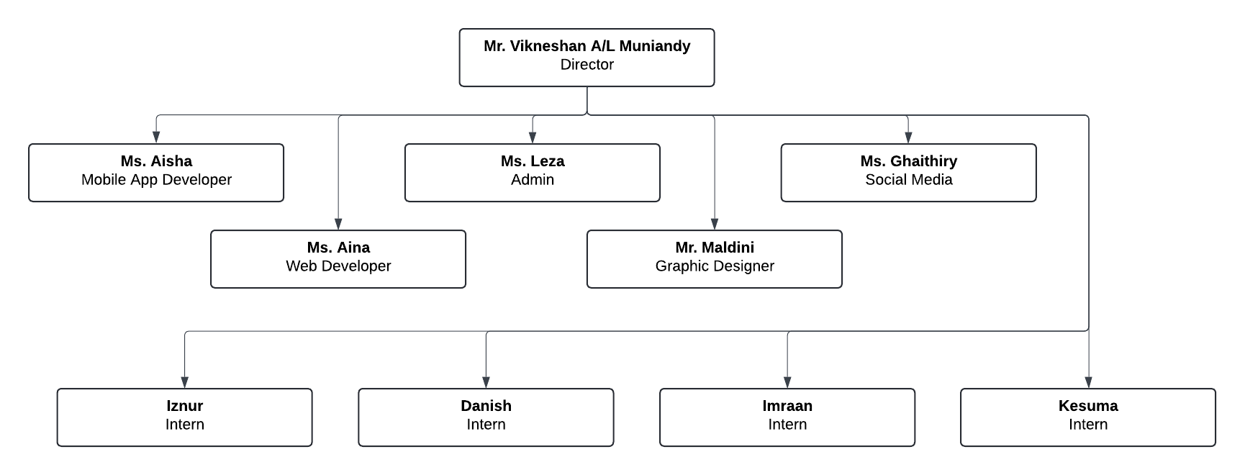

**Figure 2:** Table of organisation

**2.4 Function of Department**

1. **Director :** Responsible for setting the vision, and long-term goals, and ensuring alignment with organizational values.
2. **Web Development :** Responsible for designing, building and maintaining functional and user-friendly websites. They write clean code, troubleshoot issues, and work closely with graphic designers to implement visual elements of the front-end.
3. **Mobile App Development :** Focus on creating mobile apps for various platforms, ensuring they meet user needs and excellent UI/UX.
4. **Graphic Designer :** Creating visually compelling designs that communicate the company’s brand effectively. They produce graphics, logos, and layouts for digital platforms and marketing materials, working collaboratively with developers to ensure cohesive and engaging user interfaces.
5. **Admin :** Crucial role in managing daily office operations supporting all departments and handling administration daily tasks.
6. **Social Media :** Promote the company’s values, mission, and offerings to create a strong online presence and attract potential customers.

**3.0 ROUTINE LI TASK**

**3.1 Technical 1 (Create a brand new file editor and file manager)**

**3.1.1 Task Specification**

I was assigned to explore and learn mobile app development using the framework Ionic with Angular to understand how they integrate to create cross-platform mobile applications. It requires me to highly focus on learning the tools, components and best practices by developing the code function. This fundamental and foundational training can lead me to effectively for my future projects involving mobile application development. The task was only took 1 week to discover Ionic.

**3.1.2 Implementation and Solution Method**

A good way to learn Ionic is by utilizing the official documentation available on the Ionic website. I approach it by breaking it down section by section, which helps improve my self-learning progress and makes the process more efficient. This method allows me to grasp each concept thoroughly while building a solid foundation in Ionic development.

Step 1. Learn the Ionic basic structure

| <ion-header>  <ion-toolbar>  <ion-title>My_First_App</ion-title>  </ion-toolbar>  </ion-header>  <ion-content class="ion-padding">  <h1>Content</h1>  <ion-tabs>  <ion-tab-bar slot="bottom">  <ion-tab-button tab="home">  <ion-icon name="play-circle"></ion-icon>  Listen Now  </ion-tab-button>  <ion-tab-button tab="radio">  <ion-icon name="radio"></ion-icon>  Radio  </ion-tab-button>  <ion-tab-button tab="library">  <ion-icon name="library"></ion-icon>  Library  </ion-tab-button>  <ion-tab-button tab="search">  <ion-icon name="search"></ion-icon>  Search  </ion-tab-button>  </ion-tab-bar>  </ion-tabs>  </ion-content>  <ion-footer>  <ion-toolbar>  <ion-title>Footer</ion-title>  </ion-toolbar>  </ion-footer> |
| --- |

**Figure 3:** Ionic code structure

Step 2, Learn Ionic responsive grid

| <ion-grid>  <ion-row>  <ion-col>1</ion-col>  <ion-col>2</ion-col>  <ion-col>3</ion-col>  </ion-row>  </ion-grid>  <ion-grid>  <ion-row>  <ion-col>1</ion-col>  <ion-col>2</ion-col>  <ion-col>3</ion-col>  <ion-col>4</ion-col>  <ion-col>5</ion-col>  <ion-col>6</ion-col>  </ion-row>  </ion-grid>  <ion-grid>  <ion-row>  <ion-col>1</ion-col>  <ion-col>2</ion-col>  <ion-col>3</ion-col>  <ion-col>4</ion-col>  <ion-col>5</ion-col>  <ion-col>6</ion-col>  <ion-col>7</ion-col>  <ion-col>8</ion-col>  <ion-col>9</ion-col>  <ion-col>10</ion-col>  <ion-col>11</ion-col>  <ion-col>12</ion-col>  </ion-row>  </ion-grid> |
| --- |

**Figure 4:** Ionic responsive grid

Step 3, Integrate with the Android emulator in Android Studio

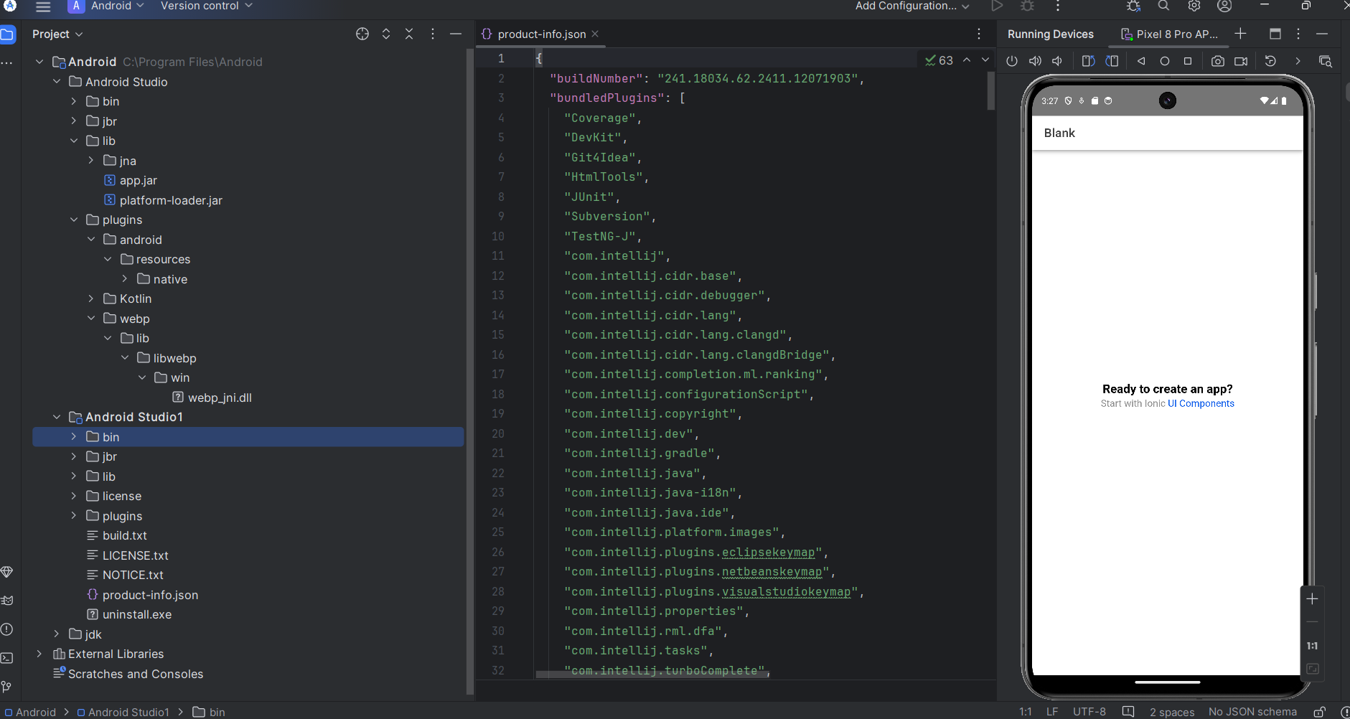

**Figure 5:** Android emulator

| <ion-header>  <ion-toolbar>  <ion-title>Welcome</ion-title>  </ion-toolbar>  </ion-header>  <ion-content class="ion-padding">  <h1>Ready to create an app!</h1>  </ion-content> |
| --- |

**Figure 6:** Ionic code structure

**3.1.3 Knowledge and Skills Gain**

From this project, I have gained an understanding of how ionic framework technology works and Cross-Platform Development. It equips me with essential skills and knowledge that are highly valuable mobile app development field.

**3.2 Technical 2 (Web Page Builder)**

**3.2.1 Task Specification**

My industrial supervisor assigned me 2nd task to test my ability to understand the objective and learn new technologies. The task that was given to me was to build a content management system (CMS) for Web Page Builder. The main purpose is, that users can build their web page without a single coding technical. This involved creating an intuitive drag-and-drop interface where users could design and manage web content seamlessly. It requires significant experience in understanding complex requirements. This task was developed independently by me for 10 weeks.

**3.2.2 Implementation and Solution Method**

For the web page builder project, I implemented the Chart.js and also Bootstrap framework to streamline the development process and ensure a responsive, mobile-friendly design. Bootstrap's pre-built components and grid system allowed for faster layout creation, making the work progress more efficient.

Other than that, I also use phpMyAdmin to manage the database, where all user data related to the web page content is stored. I believe by combining Bootstrap for the front-end and phpMyAdmin for the back-end, I ensure it will make my project a solid foundation for both usability and data management.

Step 1, Implement File Editor and File Manager from task 1.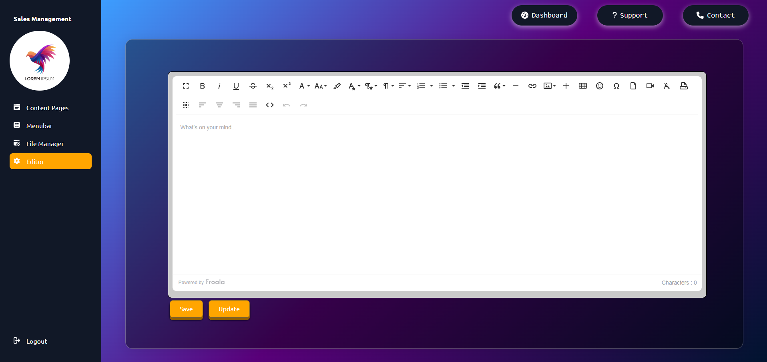

**Figure 7:** File Editor

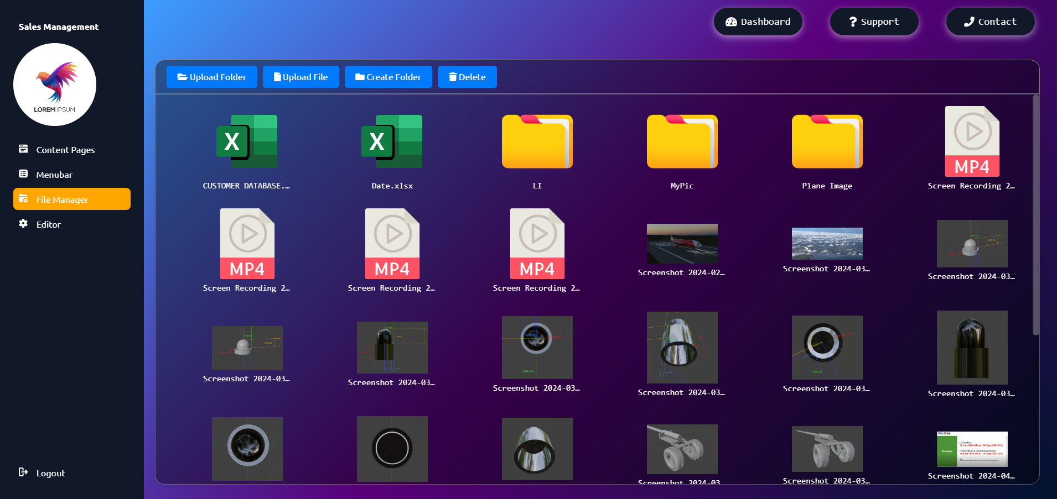

**Figure 8:** File Manager

Step 2, Create a function to save the web page content into database.

| <?php  // Database connection  $servername = "localhost";  $username = "root";  $password = "";  $dbname = "sales_management";  $conn = new mysqli($servername, $username, $password, $dbname);  // Check connection  if ($conn->connect_error) {  die("Connection failed: " . $conn->connect_error);  }  // Get the content and title from the POST request  if (isset($_POST['content']) && isset($_POST['title'])) {  $content = $_POST['content'];  $title = $_POST['title'];  // Insert the title and content into the database  $sql = "INSERT INTO userContent (title, content) VALUES (?, ?)";  // Prepare and bind  $stmt = $conn->prepare($sql);  $stmt->bind_param("ss", $title, $content);  // Execute the statement  if ($stmt->execute()) {  // Get the last inserted ID  $salesId = $conn->insert_id;  // Now update the link_column_name with the salesId  $linkSql = "UPDATE userContent SET link_column_name = ? WHERE id = ?";  $linkStmt = $conn->prepare($linkSql);  $link = "http://localhost/salesCMS/view.php?id=" . $salesId;  $linkStmt->bind_param("si", $link, $salesId);  // Execute the update statement  if ($linkStmt->execute()) {  echo "Content saved successfully";  } else {  echo "Error updating link: " . $linkStmt->error;  }  $linkStmt->close();  } else {  echo "Error: " . $stmt->error;  }  $stmt->close();  } else {  echo "Error: Title or content is missing.";  }  $conn->close();  ?> |
| --- |

**Figure 9:** Save content to database php function

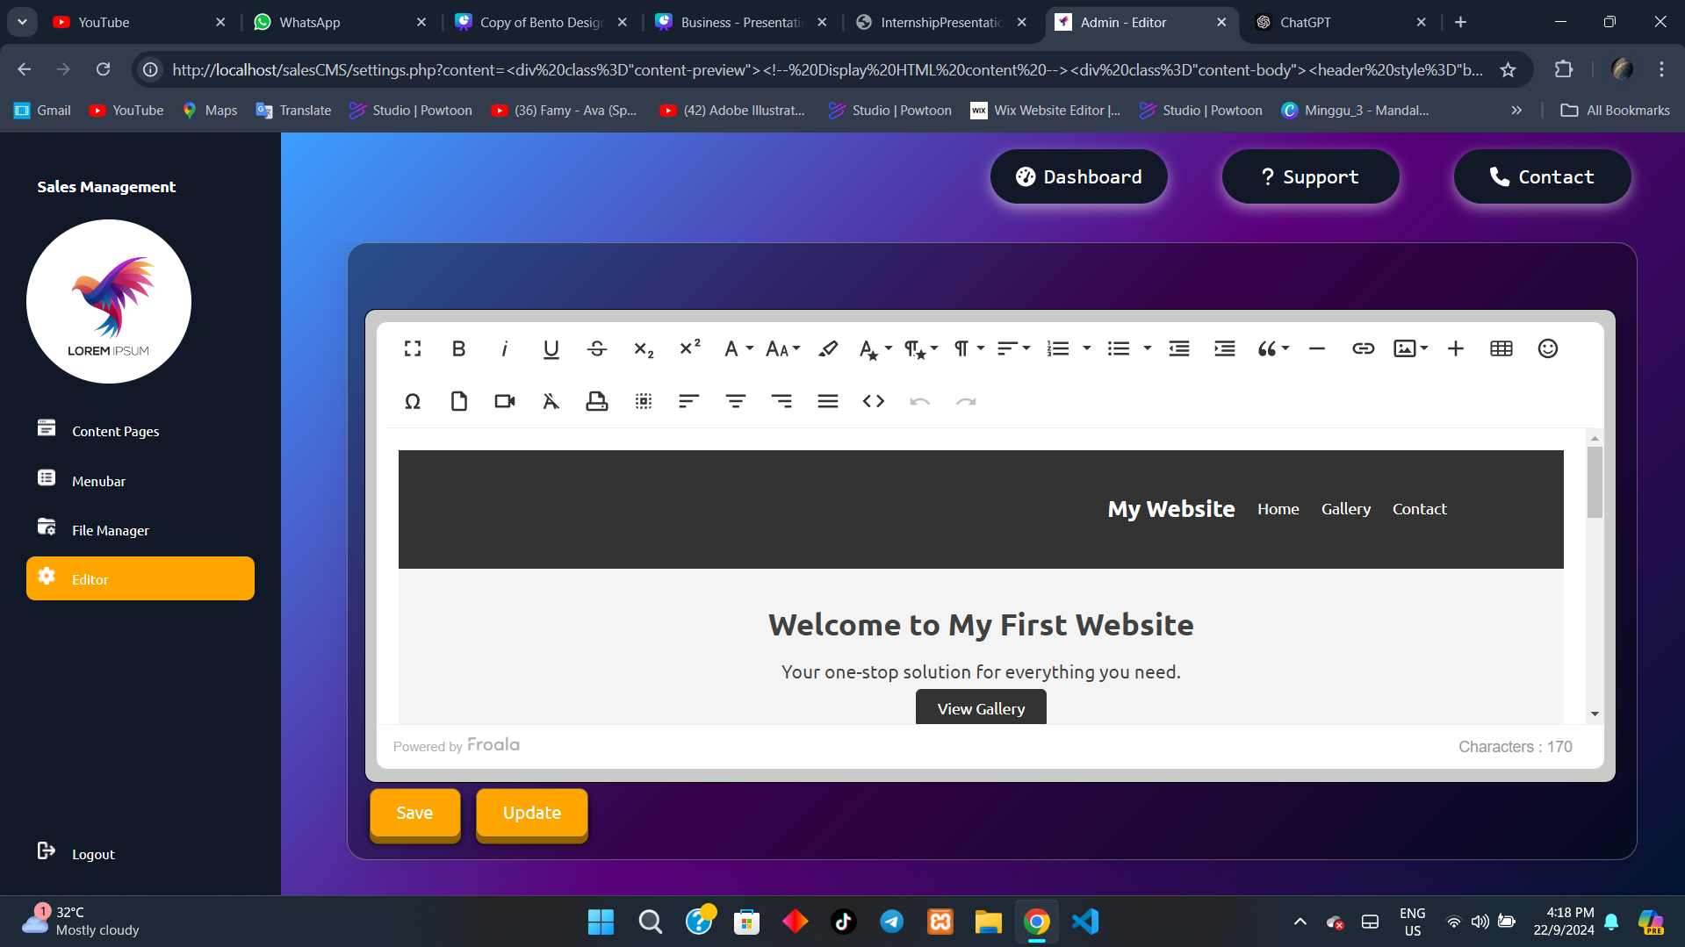

**Figure 10:** Web builder by Froala

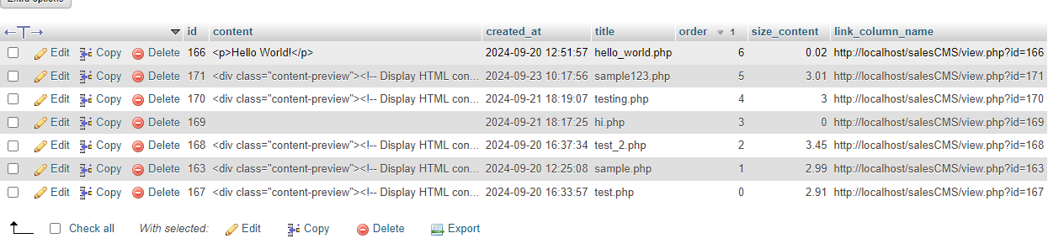

**Figure 11:** Table usercontent

Step 3, Create a function to preview the web page that has been created by the user

| <?php  $servername = "localhost";  $username = "root";  $password = "";  $dbname = "sales_management";  $conn = new mysqli($servername, $username, $password, $dbname);  if ($conn->connect_error) {  die("Connection failed: " . $conn->connect_error);  }  $id = isset($_GET['id']) ? intval($_GET['id']) : 0;  // Fetch content based on ID  $sql = "SELECT * FROM usercontent WHERE id = ?";  $title = "SELECT title FROM usercontent WHERE id =?";  $stmt = $conn->prepare($sql);  $stmt->bind_param("i", $id);  $stmt->execute();  $result = $stmt->get_result();  $content = $result->fetch_assoc();  if (!$content) {  echo "Content not found";  exit;  }  $sql_title = "SELECT title FROM usercontent WHERE id = ?";  $stmt = $conn->prepare($sql_title);  $stmt->bind_param("i", $id);  $stmt->execute();  $result_title = $stmt->get_result();  if ($result_title->num_rows > 0) {  $row = $result_title->fetch_assoc();  $title_name = $row['title'];  } else {  $title_name = "Default Title";  } $stmt->close();  ?>  <!DOCTYPE html>  <html lang="en">  <head>  <meta charset="UTF-8">  <meta name="viewport" content="width=device-width, initial-scale=1.0">  <title><?php echo htmlspecialchars($title_name); ?></title>  <link rel="stylesheet" href="https://cdnjs.cloudflare.com/ajax/libs/font-awesome/5.15.4/css/all.min.css">  <link rel="stylesheet" href="main_css/content.css">  <link rel="icon" type="image/jpeg" href="icon/title.jpg">  </head>  <body>  <div class="content-preview">  <!-- Display HTML content →  <div class="content-body">  <?php echo $content['content']; ?>  </div>  <!-- Add other content details as necessary -->  </div>  </body>  </html>  <?php  // Close connection  $conn->close();  ?> |
| --- |

**Figure 12:** Preview Web Page php function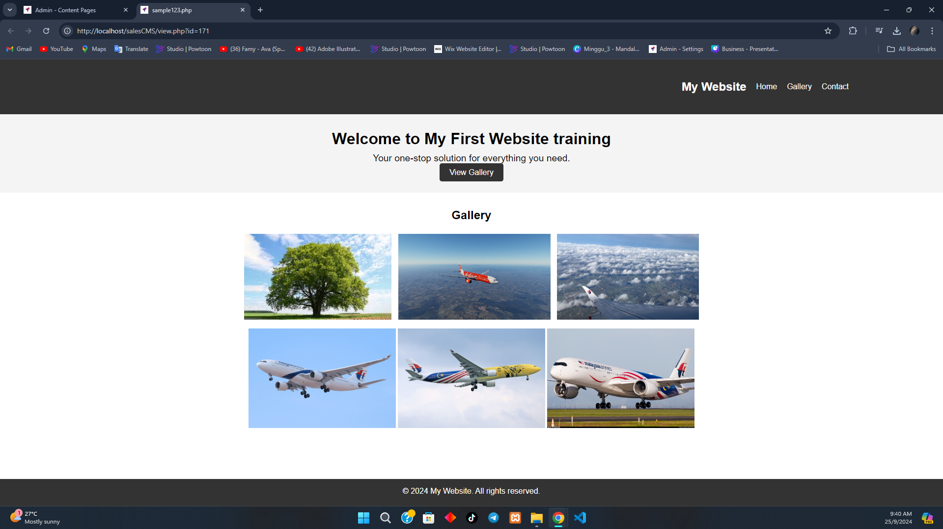

**Figure 13:** Preview Web Page php function

Step 4, Create a page to edit, remove and preview content

| <div class="gallery-header">  <div class="gallery-header-item">ID</div>  <div class="gallery-header-item">Content Title</div>  <div class="gallery-header-item creation-date-header">Creation Date</div>  <div class="gallery-header-item">Action</div>  </div>  <?php if ($result->num_rows > 0): ?>  <?php while ($row = $result->fetch_assoc()): ?>  <div class="gallery-item" data-id="<?php echo htmlspecialchars($row['id']); ?>">  <div class="gallery-item-content"><?php echo htmlspecialchars($row['id']); ?></div>  <div class="gallery-item-content"><?php echo htmlspecialchars($row['title']); ?></div>  <div class="gallery-item-content creation-date"><?php echo htmlspecialchars($row['created_at']); ?></div>  <div class="gallery-item-content gallery-item-actions">  <a href="javascript:void(0);" onclick="editContent(<?php echo htmlspecialchars($row['id']); ?>);" title="Edit">  <i class="fas fa-edit"></i>  </a>  <a href="#" onclick="removeItem(<?php echo htmlspecialchars($row['id']); ?>); return false;" title="Remove">  <i class="fas fa-trash"></i>  </a>  <a href="view.php?id=<?php echo htmlspecialchars($row['id']); ?>" title="View" target="_blank">  <i class="fa fa-eye" aria-hidden="true"></i>  </a>  </div>  </div>  <?php endwhile; ?>  <?php else: ?>  <div class="gallery-item"></div>  <?php endif; ?> |
| --- |

**Figure 14:** PHP and HTML code to display each content details

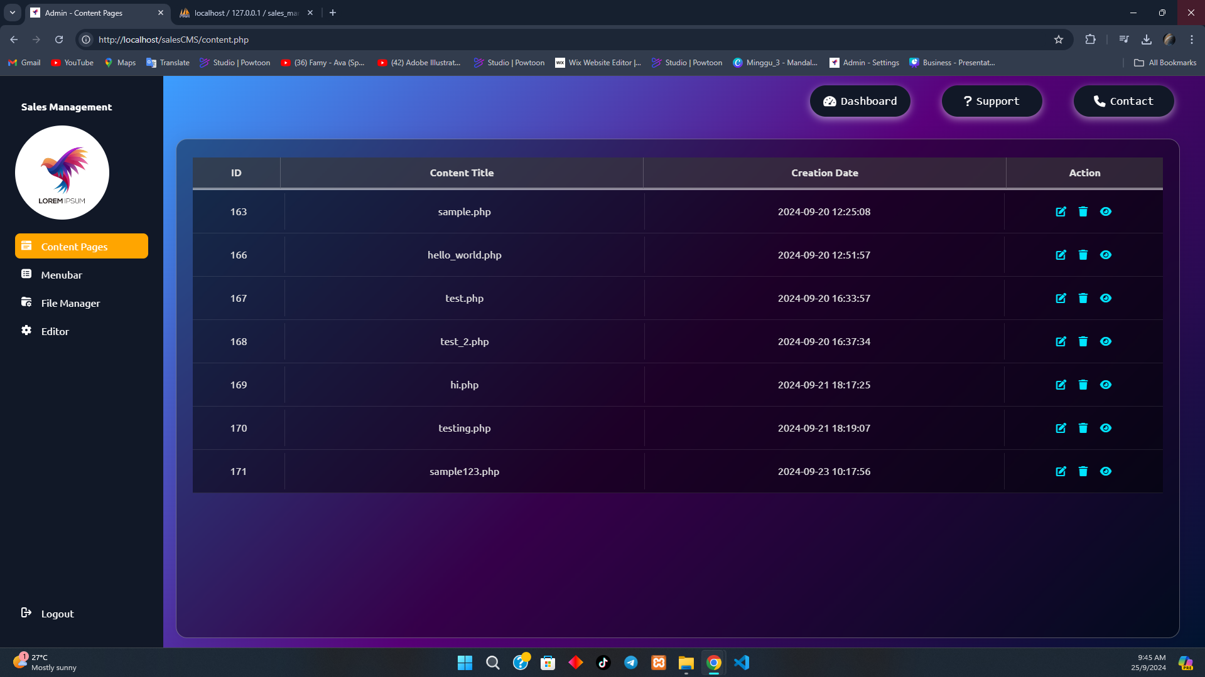

**Figure 15:** Edit, remove and preview content layout

**3.2.3 Knowledge and Skills Gain**

From task 2, I learned that building a CMS requires a strong

understanding of programming languages and the ability to

quickly identify and implement solutions. Additionally, I

recognized the importance of integrating modern web

technologies and frameworks to enhance the efficiency of the

development process. By using the tools I managed to increase

my workflow, making the project time-efficient. In my opinion,

the most important that I gained from this project is the

commitment to delivering the best possible best for my clients.

Ultimately, it is my priority and concern to deliver perfectly

and encourage me to improve my work.

**3.3 Non-technical (Video Shoot)**

**3.3.4 Task Specification**

During the video shoot for one of the company’s clients, Dr Syahzarul, a specialist in cancer and gynaecology, I was assigned to handle the voice recording and view setting. My role involved ensuring high-quality audio capture by managing the microphone and adjusting sound levels. This task requires good teamwork between the cameraman and the video shoot leader to get a perfect video.

**3.3.5 Implementation and Solution Method**

Before executing the video shoot for the company’s client, we had a quick briefing and planned the shoot meticulously to ensure everything ran smoothly. The goal was to execute the shoot perfectly and avoid any minor or major mistakes. This preparation allowed the team to align on roles, expectations, and contingencies, ensuring a seamless production process.

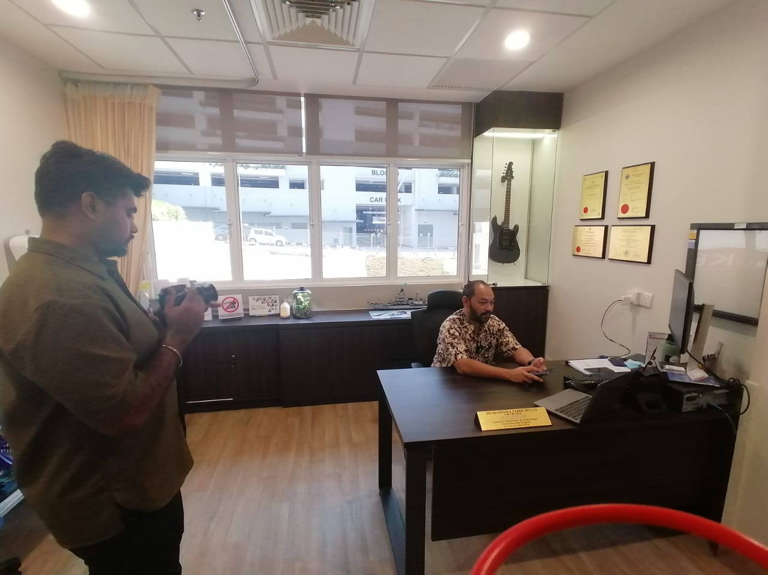

**Figure 16:** Video Shoot 1

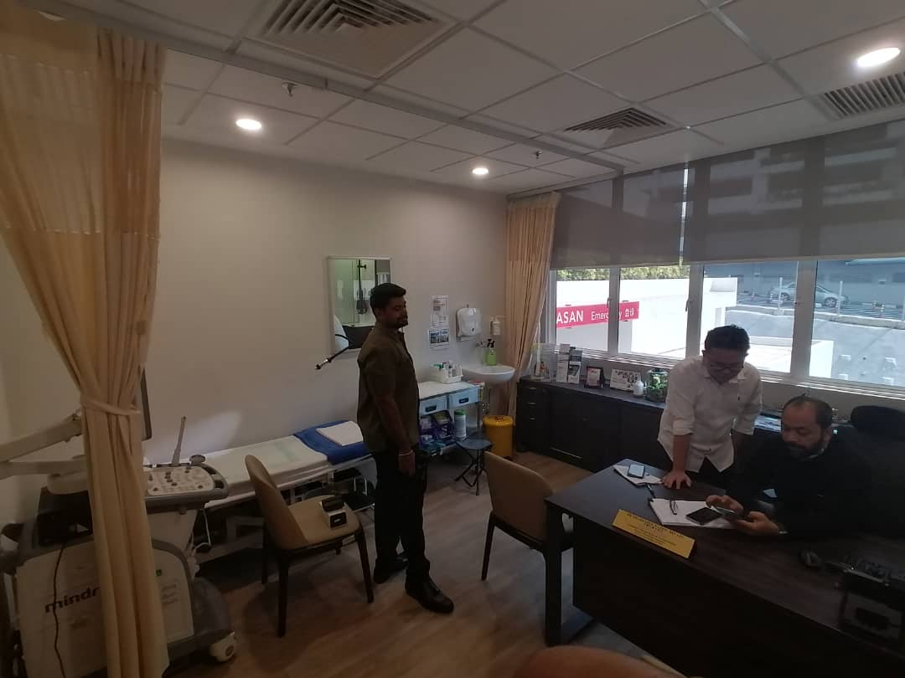

**Figure 17:** Video Shoot 2

**3.3.6 Knowledge and Skills Gain**

From this task, I gained valuable skills in maintaining high focus to capture clear and high-quality sound. Managing the sound system requires me detail attention to ensure that the audio is free from background noise and distractions. This task enhanced my ability to stay attentive to technical aspects during the shoot and to improve production quality.

**4.0 PROJECT DESCRIPTION (MAIN TASK)**

**4.1 Problem Statement**

Currently, the company are using an outdated file editor and file manager for its website production. These tools are not compatible with expanding the company business because it is not well-secured against modern threads and lack system updates.

**4.2 Task Specification** I was responsible for building and delivering a brand new file editor and

file manager. Through my research, I managed to come out with some

options of file editors that could effectively improve the company's

production such as “TinyMCE”, “Rich Editor”, “Froala” and “FileGator”.

After a long discussion with my supervisor, we decided to proceed with

“Froala” as it met the company’s criteria.

**4.3 Implementation and Solution Method** I gathered all the needs of the company’s requirements such as the

features, design and layout.Based on this input, I outlined the important functions, For example, file type support and security measures. After selecting the most suitable solution, I proceeded with the development phase by implementing requirements gathering methodology references.

Step 1, Step 1. Integrate Froala as the Editor

| // Froala  new FroalaEditor('#edit', {  toolbarButtons: [  'fullscreen', 'bold', 'italic', 'underline', 'strikeThrough', 'subscript',  'superscript', 'fontFamily', 'fontSize', 'color', 'inlineStyle', 'paragraphStyle',  'paragraphFormat', 'align', 'formatOL', 'formatUL', 'outdent', 'indent', 'quote',  'insertHR', 'insertLink', 'customInsertImage', 'insertDiv', 'insertTable', 'emoticons',  'specialCharacters', 'insertFile', 'insertVideo', 'clearFormatting', 'print', 'html',  'undo', 'redo'  ],  imageInsertButtons: ['imageBack', '|', 'customInsertImage'],  heightMin: 300,  widthMin: 900,  placeholderText: "What's on your mind...",  pluginsEnabled: [  'align', 'charCounter', 'codeBeautifier', 'codeMirror', 'codeView', 'colors', 'draggable',  'embedly', 'emoticons', 'entities', 'file', 'fontAwesome', 'fontFamily', 'fontSize',  'fullscreen', 'image', 'imageManager', 'imageTUI', 'inlineClass', 'inlineStyle',  'lineBreaker', 'lineHeight', 'link', 'lists', 'paragraphFormat', 'paragraphStyle',  'print', 'quickInsert', 'quote', 'save', 'specialCharacters', 'table', 'url',  'video', 'wordPaste'  ]  });  // Insert Table Div  FroalaEditor.DefineIcon('insertDiv', { NAME: 'table', SVG_KEY: 'add' });  // Register the 'Insert Table' command  FroalaEditor.RegisterCommand('insertDiv', {  title: 'Insert Div',  icon: 'insertDiv',  focus: true,  undo: true,  refreshAfterCallback: true,  callback: function () {  // Define the HTML for the custom table  var tableHTML = `  <table class="fr-dashed-borders fr-alternate-rows" style="width:100%;">  <tbody>  <tr>  <td style="text-align:center;">  <br><span style="font-size:24px;"><a href="https://froala.com/wysiwyg-editor/docs/" title="Documentation" style="text-decoration: none; color: #0098f7;"><strong>Documentation</strong></a>&nbsp;</span></td>  <td style="text-align: center;">  <br><span style="font-size:24px;"><a href="https://froala.com/wysiwyg-editor/docs/" title="Report" style="text-decoration: none; color: #0098f7;"><strong>Report</strong></a>&nbsp;</span></td>  <td style="text-align: center;">  <br><span style="font-size:24px;"><a href="https://froala.com/wysiwyg-editor/docs/" title="Analysis" style="text-decoration: none; color: #0098f7;"><strong>Analysis</strong></a>&nbsp;</span></td>  </tr>  </tbody>  </table>  `;  // Insert the table into the editor at the current cursor position  this.html.insert(tableHTML);  // Make each cell adjustable independently  var $cells = this.$el.find('td').slice(-3);  // Function to update cell width  function updateCellWidth($cell) {  $cell.css('width', 'auto');  }  // Attach resize event listener to each cell  $cells.each(function() {  var $cell = $(this);  var observer = new ResizeObserver(function() {  updateCellWidth($cell);  });  observer.observe(this);  });  }  });  // Insert Image, File, Folder, Browse  FroalaEditor.DefineIcon('customInsertImage', { NAME: 'image', SVG_KEY: 'insertImage' });  // Register the 'Insert Image' command  FroalaEditor.RegisterCommand('customInsertImage', {  title: 'Insert Image',  type: 'dropdown',  focus: true,  undo: true,  refreshAfterCallback: true,  options: {  'imageUpload': 'Upload File',  'folderUpload': 'Upload Folder',  'imageBrowser': 'Browse Images',  },  callback: function (cmd, val) {  if (val === 'imageUpload') {  imageUploadInput.click();  } else if (val === 'imageBrowser') {  console.log('Image browser selected');  updateImageGallery();  } else if (val === 'folderUpload') {  document.getElementById('documentFolderUploadInput').click();  }  }  }); |
| --- |

**Figure 18:** Froala code

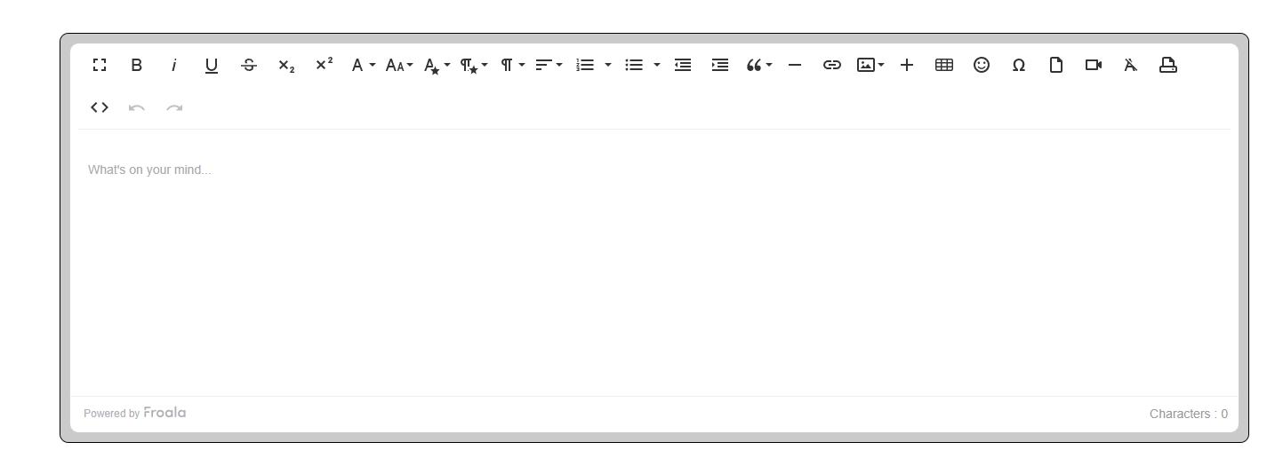

**Figure 19:** Froala Editor

Step 2, Implement code to the correct directories

| <?php  $directory = 'C:/xampp/htdocs/MyMCE/file-web/CDN';  $items = [];  function getDirectoryContents($dir, &$items) {  if ($handle = opendir($dir)) {  while (false !== ($entry = readdir($handle))) {  if ($entry != "." && $entry != "..") {  $path = $dir . '/' . $entry;  $type = is_dir($path) ? 'folder' : mime_content_type($path);  $items[] = ['name' => $entry, 'path' => $path, 'type' => $type];  if (is_dir($path)) { getDirectoryContents($path, $items);}  }} closedir($handle);  }}getDirectoryContents($directory, $items);  header('Content-Type: application/json');  echo json_encode($items); |
| --- |

**Figure 20:** Identify path php function

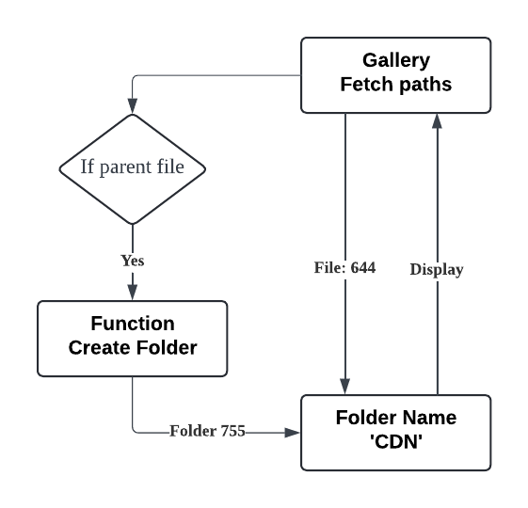

**Figure 21:** Fetch directories flow

Step 3, Create the gallery layout and design to display the directory content. 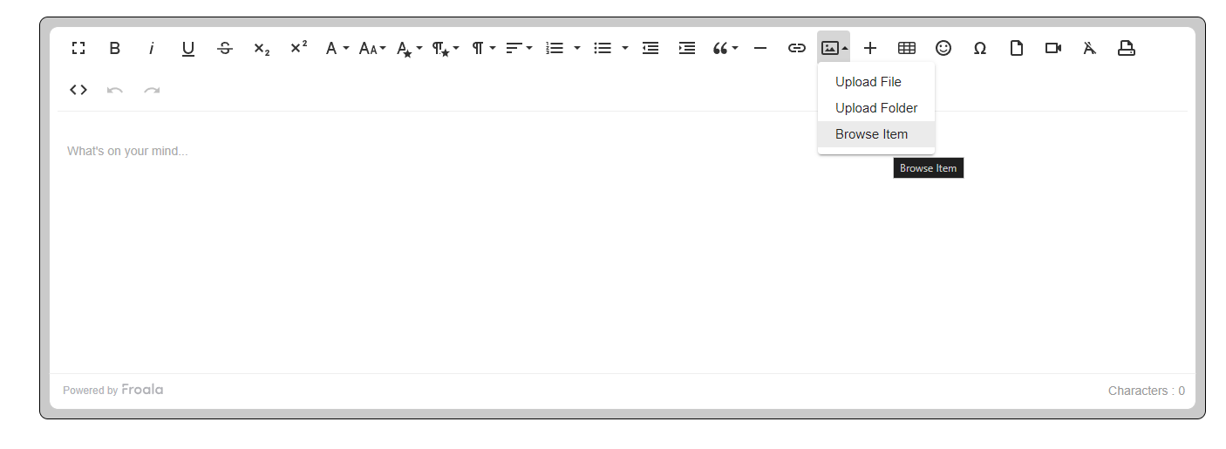

**Figure 22:** File editor gallery button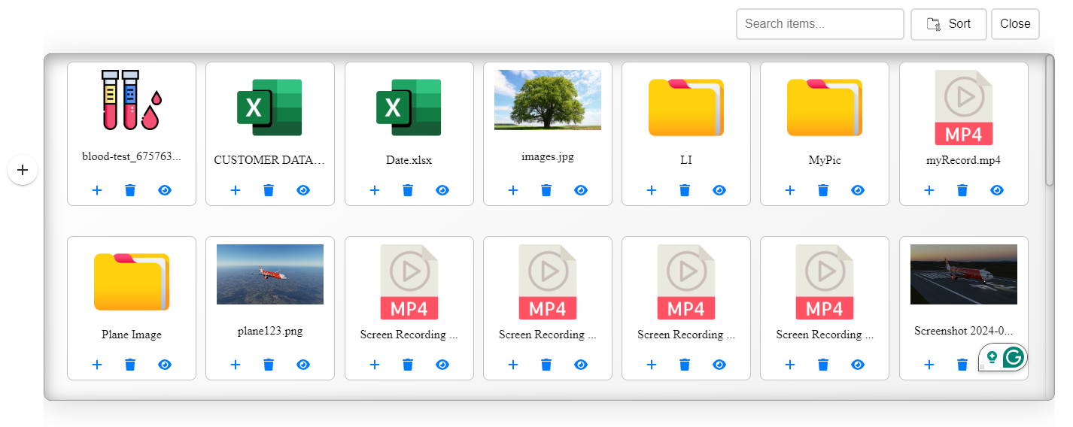

**Figure 23:** Gallery of directories

Step 4, Create a preview item div that pops up when the preview icon is triggered to click.

**Figure 24:** Gallery of directories

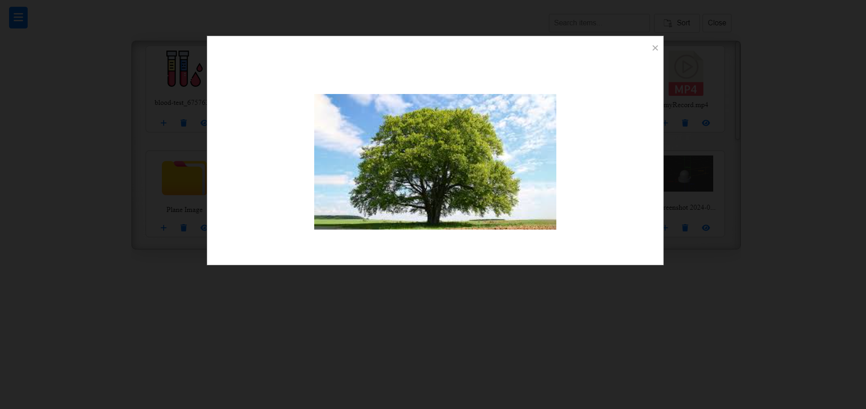

**Figure 25:** Preview image type

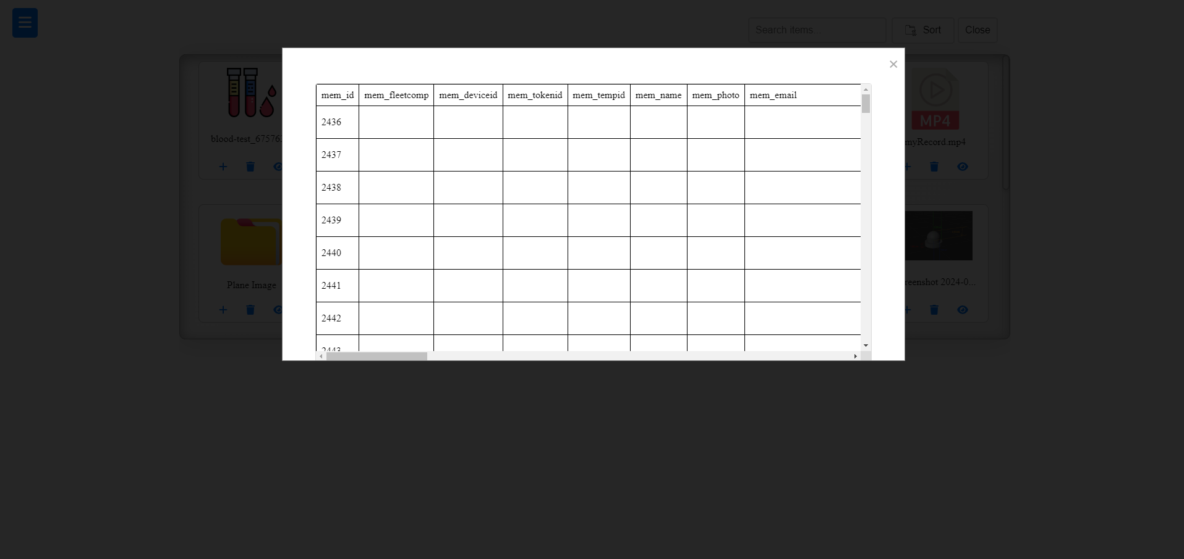

**Figure 26:** Preview file XLSX type

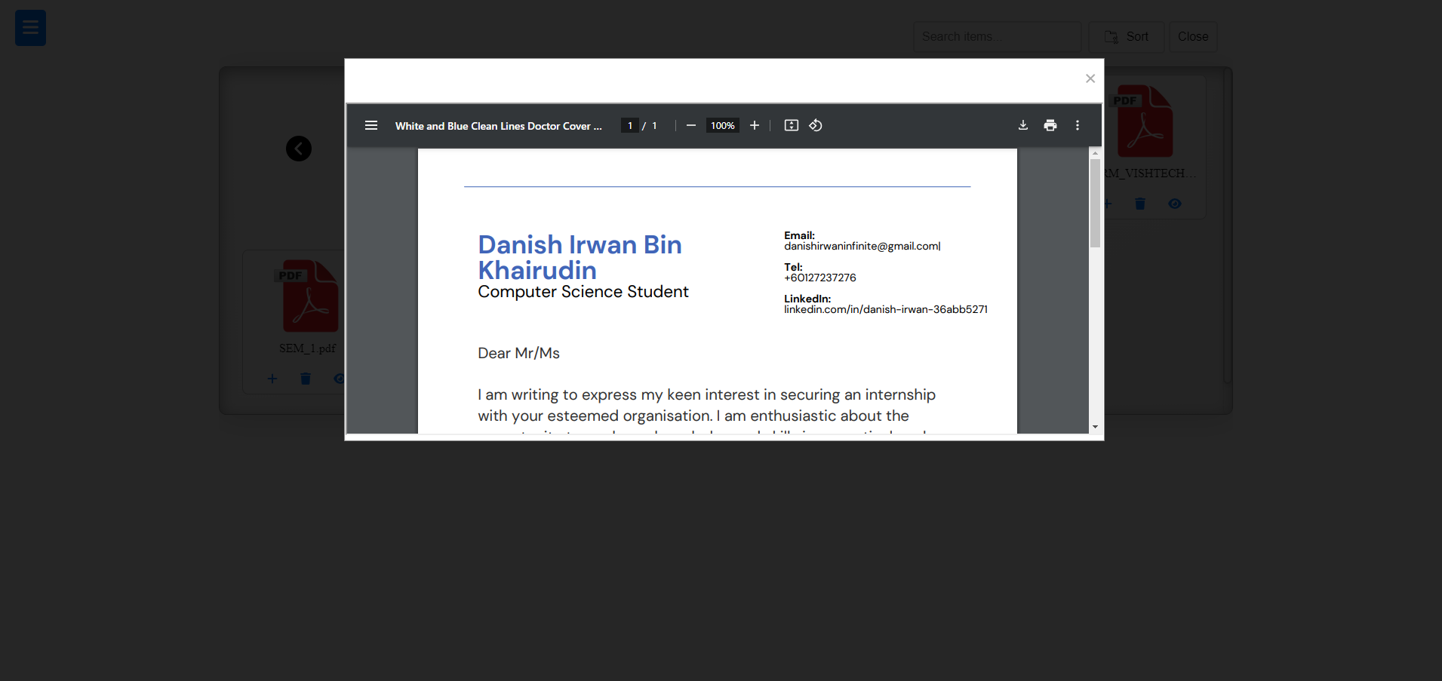

**Figure 27:** Preview file PDF type

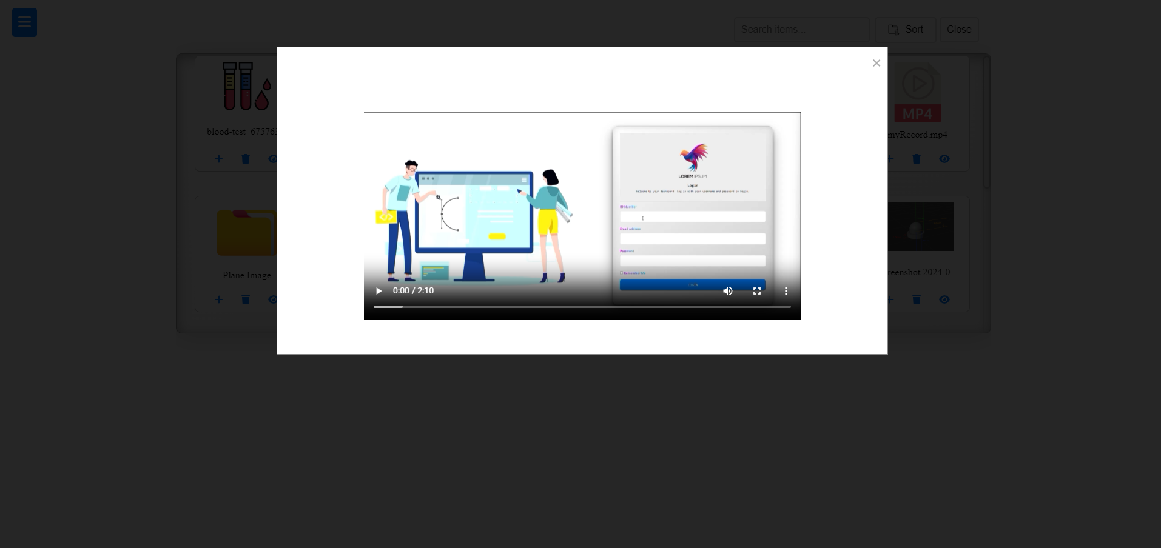

**Figure 28:** Preview file MP4 type

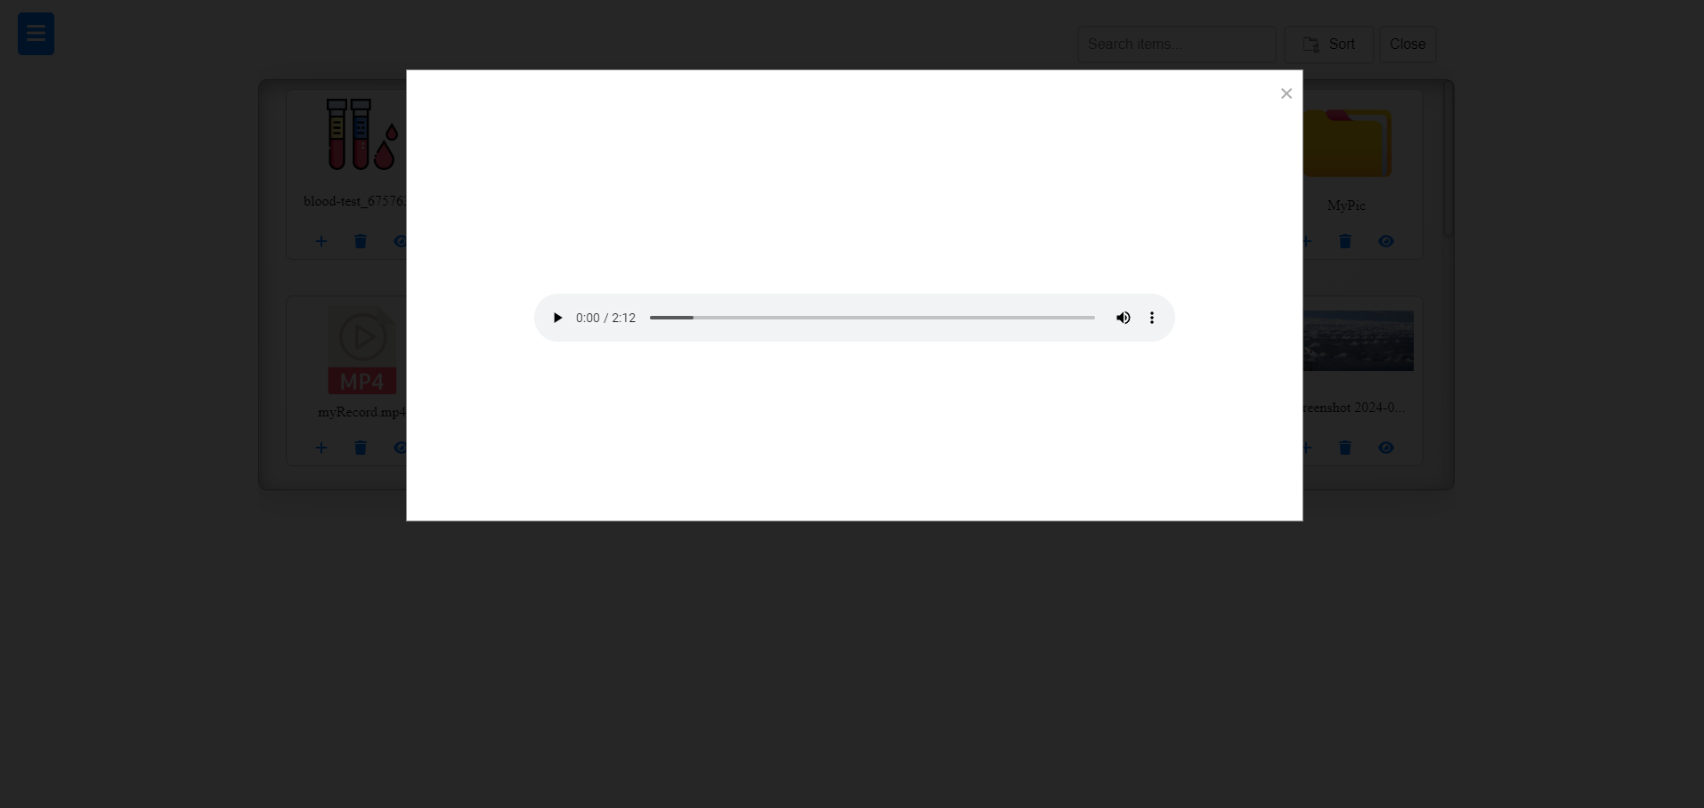

**Figure 29:** Preview file MP3 type

| function previewItem(fileUrl, fileType, fileName) {  const modalContent = document.getElementById('modalContent');  modalContent.innerHTML = '';  const fileExtension = fileUrl.split('.').pop().toLowerCase();  if (['jpg', 'jpeg', 'png', 'gif'].includes(fileExtension)) {  const img = document.createElement('img');  img.src = fileUrl;  img.alt = 'Preview';  img.style.maxWidth = '80%';  img.style.maxHeight = '80%';  modalContent.appendChild(img);  } else if (fileExtension === 'pdf' || fileExtension === 'docx') {  const iframe = document.createElement('iframe');  iframe.src = fileUrl;  iframe.style.width = '90%';  iframe.style.height = '90%';  modalContent.appendChild(iframe);  } else if (fileExtension === 'txt') {  fetch(fileUrl)  .then(response => response.text())  .then(text => {  const pre = document.createElement('pre');  pre.textContent = text;  pre.style.width = '100%';  pre.style.height = '95%';  pre.style.marginTop = '50px';  pre.style.overflow = 'auto';  modalContent.appendChild(pre);  })  .catch(error => {  console.error('Failed to load text file', error);  const message = document.createElement('p');  message.textContent = 'Failed to load text file.';  modalContent.appendChild(message);  });  } else if (fileExtension === 'xlsx') {  fetch(fileUrl)  .then(response => response.arrayBuffer())  .then(data => {  const workbook = XLSX.read(data, { type: 'array' });  const sheetName = workbook.SheetNames[0];  const worksheet = workbook.Sheets[sheetName];  const html = XLSX.utils.sheet_to_html(worksheet);  const div = document.createElement('div');  div.innerHTML = html;    // Add styles to the table and container  const style = document.createElement('style');  style.textContent = `  .table-container {  height: 450px; /* Set the height of the scrollable area */  width: 1000px;  overflow-y: auto; /* Add vertical scrollbar */  overflow-x: auto; /* Add vertical scrollbar */  border: 1px solid #ddd; /* Optional: border around the container */  margin-top: 10px; /* Optional: space between modal content and table */  }  table {  border-collapse: collapse;  width: 100%;  }  th, td {  border: 1px solid black;  padding: 8px;  text-align: left;  }  th {  background-color: #f2f2f2;  }  `;  div.appendChild(style);    // Create and append the container div  const container = document.createElement('div');  container.className = 'table-container';  container.appendChild(div);  modalContent.appendChild(container);  })  .catch(error => {  console.error('Failed to load Excel file', error);  const message = document.createElement('p');  message.textContent = 'Failed to load Excel file.';  modalContent.appendChild(message);  });  } else if (fileExtension === 'mp3') {  const audio = document.createElement('audio');  audio.src = fileUrl;  audio.controls = true;  audio.style.width = '80%';  modalContent.appendChild(audio);  } else if (fileExtension === 'mp4') {  const video = document.createElement('video');  video.src = fileUrl;  video.controls = true;  video.style.width = '80%';  modalContent.appendChild(video);  }  const modal = document.getElementById('previewModal');  modal.style.display = 'block';  const closeButton = document.querySelector('.close');  closeButton.onclick = () => {  modal.style.display = 'none';  };  window.onclick = (event) => {  if (event.target === modal) {  modal.style.display = 'none';  }  };  } |
| --- |

**Figure 30:** Preview JavaScript code

**4.4 Results of Task/Project** As a result of my efforts, I successfully completed the task and delivered

the project to my supervisor. The file editor and file manager system were then integrated into the company’s content management system, representing a brand new and secure version developed independently by me. The entire project took six weeks to complete, followed by an additional week dedicated to fixing minor errors and adding extra features. This experience not only enhanced my technical skills but also demonstrated my ability to manage a project from inception to deployment effectively. This task was completed under the supervision of my supervisor, who provided guidance and feedback throughout the process. Their support was a true necessity in helping me navigate challenges and ensure the project met the company’s requirements.

**4.5 Advantage, Disadvantage and Suggestion for Task Improvement** Firstly, the advantage of this project I managed to create a file

editor and file manager similar to the paid version. This project allows

users to navigate their folders and files within the directories effortlessly,

eliminating the need for manual searches on the local disk. The system is

designed to be time-saving and user-friendly, streamlining the file

management process. Also, it offers cost-saving for the company to avoid

spending more on software.

Other than that, a disadvantage of the project is that some types of files and folders may not be supported due to limitations in the system's

data-handling capabilities. This issue can be addressed by dedicating

additional time to expand the system's data-handling processes and

restructure the system environment. With further research and planning, it

is possible to enhance compatibility and support a wider range of file types

and folder structures.

Last but not least, I would like to suggest an improvement for this

project is the implementation of proper project documentation so that in

future expansion it will help the company’s developer to add and modify

the system. With well-organized documentation will provide clear

guidance of the system structure, functionalities and codebase. In this way,

the company can enhance its production efficiency and remain sustainable

and adaptable to future needs.

**4.6 Knowledge and Skills Gain**

From this project, I have gained problem-solving skills the challenging part is to solve the directories to the correct path. Also, creating the layout to load the real-time item that aligns with the “CDN” folder path. This task was fully developed by me, giving me hands-on experience in overcoming technical difficulties and enhancing my ability to work independently.

**5.0 CONCLUSION**

**5.1 Contribution Towards Organization**

For the past ten weeks of industrial training, I have gained a lot of skills

and knowledge from my given task. Despite the relatively short duration, I

believe I contributed 110% effort to the company, fully dedicating myself

to each project. This experience allowed me to not only grow technically

but also to make meaningful contributions to the company’s objectives.

**5.2 Conclusion**

To wrap up, it was an amazing journey in my industrial training that proves it is important to gain experience and skills from the professional. Without a doubt, it taught me many things such as the environment, time management and also communication skills. This golden opportunity is something I couldn't afford to miss, and I made sure to seize every single moment to learn and grow in my field.

Furthermore, my supervisor has guided me to improve certain aspects, such as task management, achieving objectives more efficiently, and enhancing my ability to learn independently. I believe these insights and lessons will contribute significantly to making me a better programmer in the future, helping me tackle challenges with greater confidence and skill.

As shown above, there is one word that best describes my internship: **“Transformative.”** It represents the growth, learning, and significant experiences I’ve gained, both personally and professionally, throughout my industrial training. From the bottom of my heart, I truly enjoyed this wonderful working experience. As the proverb goes, "Fall 7 times, get up 8," this experience serves as a valuable ticket to enhance my professional growth and working value.

**REFERENCE**

VISHTECH Website :[www.vishtech.com.my](http://www.vishtech.com.my)

VISHTECH Facebook :[www.facebook.com/vishtech](https://www.facebook.com/vishtech)

VISHTECH Instagram :[www.instagram.com/vishtech_webdesign](http://www.instagram.com/vishtech_webdesign)

**SENARAI SEMAK**